Project Design Phase-II
Data Flow Diagram & User Stories
Team ID | SWTID-2026-2439
Project Name | Import Data using Transform Maps (Spreadsheet)
Data Flow Diagrams:
A Data Flow Diagram (DFD) is a traditional visual representation of the information flows within a system. A neat and clear DFD can depict the right amount of the system requirement graphically. It shows how data enters and leaves the system, what changes the information, and where data is stored.
Processes and Data Stores in this Project:
Ref. | Name | Description
1.0 | Load Data (Import Set) | The Excel file (Sample Spreadsheet.xlsx) is uploaded through System Import Sets > Load Data and its rows are stored in the staging table.
2.0 | Transform Map (field mapping) | The Transform Map “Sample Spreadsheet Import” maps the source fields to the target fields using Auto Map Matching Fields / Mapping Assist.
3.0 | Coalesce Check (Employee ID) | Each incoming Employee ID is compared with existing records: a new ID is inserted, a matching ID is updated, and an unchanged record is ignored.
4.0 | Verify Results (Transform History) | Transform History and the Import Log show the total, inserts, updates, ignored, skipped and error counts for every load.
5.0 | Reports & Dashboard | Reports (pie, bar, list) are built on the target table and combined on the Employee Analytics Dashboard for HR.
D1 | Employee Import (u_employee_import) | Import Set (staging) table that holds the raw spreadsheet rows before transformation.
D2 | Employee Test (u_employee_test) | Custom target table holding the final employee records: Employee ID, Employee Name, Email, Department, Location.
Example: Data Flow Diagram (Level 1)
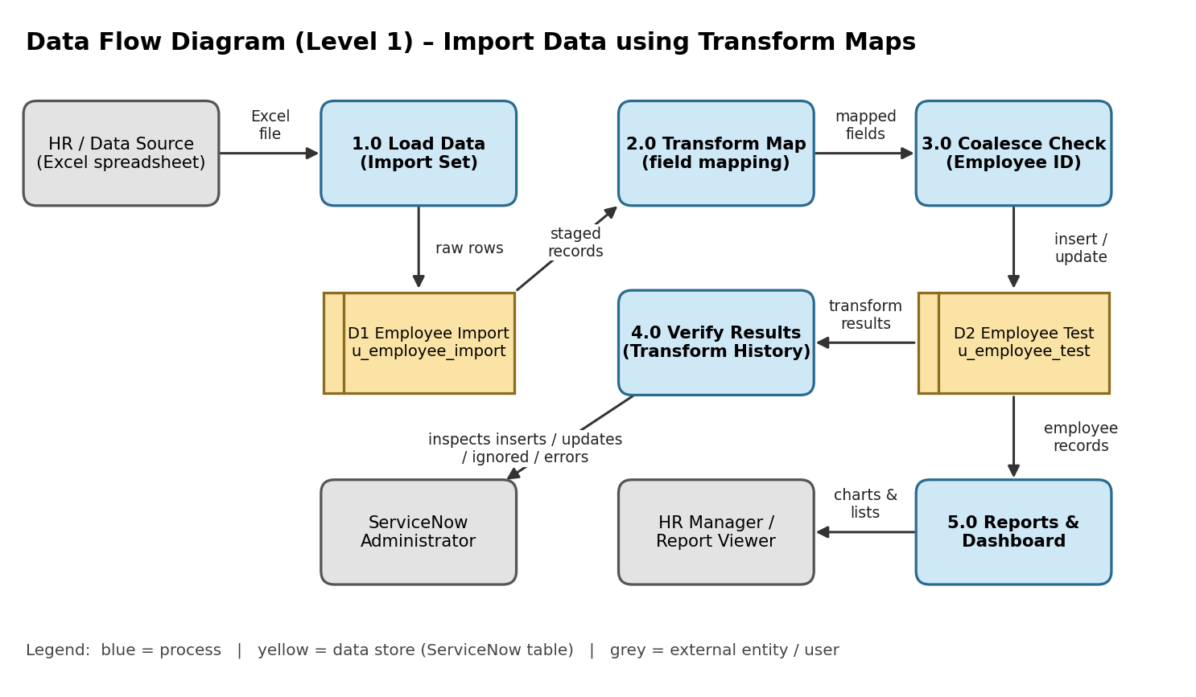
User Stories
Use the below template to list all the user stories for the product.
User Type | Functional Requirement (Epic) | User Story Number | User Story / Task | Acceptance criteria | Priority | Release
Administrator (ServiceNow) | Data Preparation | USN-1 | As an administrator, I can create a custom table Employee Test (u_employee_test) with the fields Employee ID, Employee Name, Email, Department and Location. | The table and its 5 String fields appear on the Employee Test form | High | Sprint-1
 | Data Import (Import Set) | USN-2 | As an administrator, I can upload Sample Spreadsheet.xlsx using Load Data so that its rows are stored in the Import Set table Employee Import (u_employee_import). | Progress page shows State Complete, Completion code Success and 15 records processed | High | Sprint-1
 | Field Mapping & Transformation | USN-3 | As an administrator, I can create a Transform Map from Employee Import to Employee Test and auto-map the matching fields. | Field Maps list shows all 5 source fields mapped to target fields | High | Sprint-1
 |  | USN-4 | As an administrator, I can run the Transform so the staged records are created in the target table. | Transformation completes with Success and 15 records appear in Employee Tests | High | Sprint-1
 | Duplicate Prevention (Coalesce) | USN-5 | As an administrator, I can enable Coalesce on Employee ID so that repeated imports update existing records instead of inserting duplicates. | Changed rows are updated, new IDs are inserted, and re-importing the same file inserts and updates 0 rows | High | Sprint-2
 | Verification | USN-6 | As an administrator, I can open Transform History to see the total, inserts, updates, ignored, skipped and errors for each import. | Transform History lists each load with its counts (e.g., Total 4, Inserts 2, Updates 2) | Medium | Sprint-2
HR Manager / Report Viewer | Reports | USN-7 | As an HR manager, I can view a pie chart of employees by department. | Pie chart shows the employee count for each department | Medium | Sprint-3
 |  | USN-8 | As an HR manager, I can view a bar chart of employees by location. | Bar chart shows the employee count for each location | Medium | Sprint-3
 |  | USN-9 | As an HR manager, I can view a list report of all employees with ID, name, email, department and location. | List shows every record in Employee Test with the 5 columns | Medium | Sprint-3
 | Dashboard | USN-10 | As an HR manager, I can see all three reports together on the Employee Analytics Dashboard. | Dashboard displays the department, location and list widgets | High | Sprint-3
Administrator (ServiceNow) | Dashboard Sharing | USN-11 | As an administrator, I can share the dashboard with selected users, groups and roles. | Share panel allows access to be restricted to chosen users, groups and roles | Low | Sprint-3

